“We Sloshed you with Martini’s.. But that ‘aint ‘ ardly fair”

A Study of the Martini Henry Rifle of the Zulu Wars
By Neil Aspinshaw

If only you could have read the thoughts’ of Private 1416 Caleb Wood, B company 2nd battalion 24th Regiment of foot as he peered into the murky dawn of Zululand, it was Thursday 23rd January 1879. Only 10 miles away, 800 of his friends and regiment lay dead and ritually disembowelled by his foe at a strange place the Zulu call Isandlwana.

To Wood, the pain of his burned fingers and aching shoulder was proof indeed that he was still alive. Looking around at the astonished faces of his company, he instinctively dropped the lever under the breech of his rifle, cursing the boiling oil that was seeping from the super heated walnut. He no doubt slid another round into the chamber as he had done 300 times in the last ten hours, and steeled himself for the final, inevitable few minutes of his life. But the Zulu’s were to come no more, Wood and his 103 comrades had held out for over ten hours against odds of 40-1 and remarkably had been victorious.

Caleb Wood died in Ruddington, Nottinghamshire in1927, as a defender of the Mission station at Rorkes Drift he would no doubt have poured scorn on the 1964 film Zulu, but in the 40 years since the film was made a new upsurge of interest has grown, not only in Great Britain, but worldwide into the “small wars” of the late 19th Century, and, inevitably into the weapons and tactics of a long forgotten age. In particular the rifle that was to play a major part in the British campaigns of the 1870’s and 80’s, The .450/.577” Martini Henry.

History & Development.

The changes in military rifle taking place all over Europe during that second half of 19th Century took had left military planners both in Great Britain and Europe in a dilemma. The introduction of the Dreyse Pattern 1868 Needle fire rifle had set about the accelerated development of the breech loading rifle as a weapon of choice all in industrialised countries. The trend too, for smaller projectiles with a great ballistic accuracy and velocity were beginning to become the requirement.

In Great Britain, the relatively slow movement towards breech loading firearms had seen little upgrades to the Pattern 1853 percussion, muzzle loading .577” Enfield rifle, which had been the mainstay of service ordnance. The P1853 had been produced in vast numbers and had seen over 900,000 exported to the Confederate and Union armies during the American civil war. The swing towards self-contained cartridges and breech loading firearms saw the introduction of the P1866 – Snider Enfield conversion trapdoor breech. The Snider was a simple P1853 rifle with a hinged breech to take a .577” centre fire cartridge. The hammer drove a central rod, contained in the Snider block, which in turn exploded the primer. It was effective and very popular, albeit being a simple stopgap.

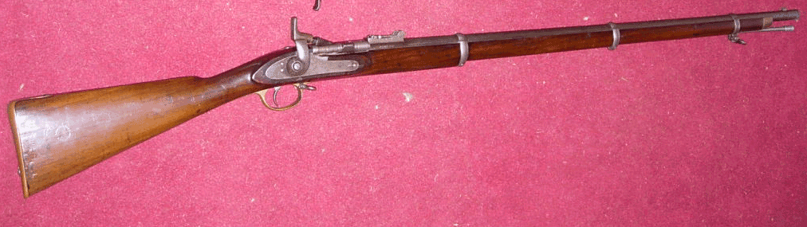
The Snider .577 Rifle

In order to select the next generation of military rifles, the British War office held a prize competition in 1867 to select from various designers a weapon that utilised a smaller, higher velocity projectile than the .577” snider. The trials were to take place within the next two years, with an ultimate winner to be announced in 1869.

The resultant competition saw various well know names in gun manufacture offer prototypes for consideration, entrants were Messrs Peabody, Henry, Fosbery, Albibi/Brendalin, Burton, Martini, Joslyn and Remington. However the resulting test proved inconclusive with no particular rifle achieving the desired performance criteria. Two examples however had stood out, but each rifle had its shortcomings. It was only when the best attributes of each design were put together that a simple and effective rifle was born.

The favoured action was that of Frederich Martini, (1833-1897) a Swiss gun maker of Hungarian origin. Martinis’ action was a simple falling block action. Martini had been accused, (quite rightly in reality), of improving and re-engineering the American Peabody falling block mechanism. Martini had devised a block that held an enclosed striker. The action of the under lever dropped the block, cocked the mechanism and ejected the spent round in one action. His selected cartridge was a .450” calibre Boxer brass round very similar in design to the American 45/70. The designation was to be the long chamber Martini .
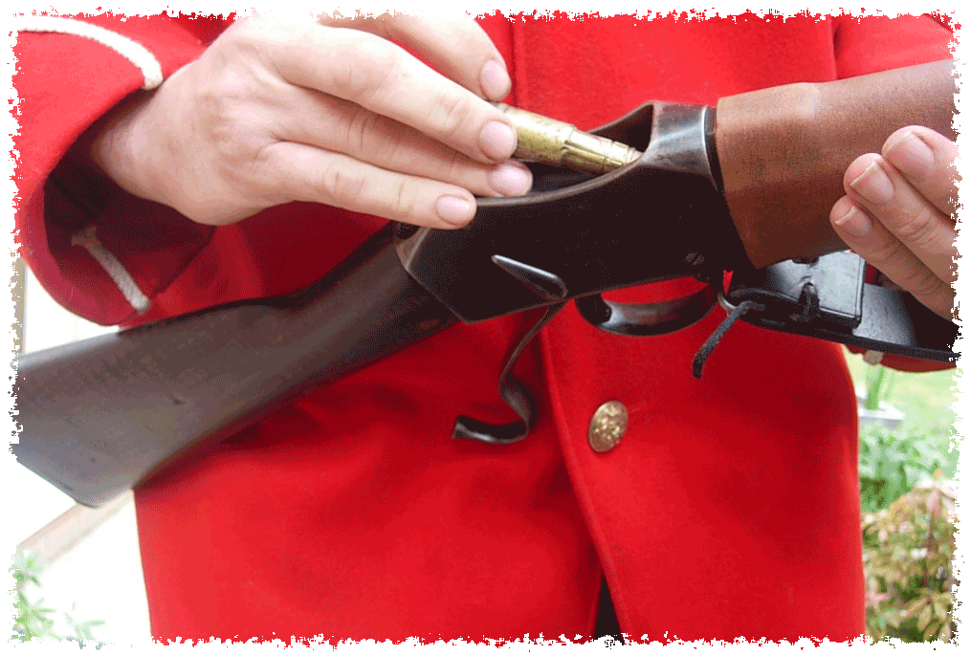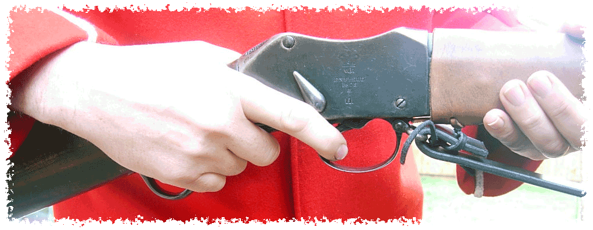
The underlever is depressed and the breech is opened allowing the cartridge to be inserted.

The action is now cocked and ready to fire, the cocking indicator is now in the rearward position

Martini had designed a simple nipple shaped cocking indicator which was to extend in the thumb-grip, however this was discontinued and a tear shaped indicator was added to the trigger axis, this was mounted on the side of the action and gave a simple, visual indication. Also a simple safety catch was installed on the right side of the action.

The spent cartridge is ejected by a downwards pull on the lever, with this action the case with flick directly clear of the breech and leave a trail of black powder smoke in its wake. One problem that was a regular complaint was the soldered base of the cartridge often detached.

The rifling system selected was that of Edinburgh gunsmith Alexander Henry, (1817-1895) which consisted of a seven groove polygonal rifling, with one twist in 22” (56cm). The barrel length was to be 33.2” (84.2cm). The Henry rifling system was found superior in all trials. The basis of the rifling was in reality a modernisation of the Whitworth system, which was developed in 1854. The bore was .450” calibre, across the lands of the rifling .458”-.464”.

The first trials pattern P1871 Martini Henry rifle were manufactured the Royal Small Arms factory at Enfield lock, of which over 200 examples were made. The main result of the field testing was that a revision was to be made to the chamber and the powder load increased to achieve a satisfactory velocity at 1300 feet per second (400m/ps). Cartridge manufacturer, Eley, had been independently experimenting with a bottle shaped Boxer round. The increased load and shorter chamber requirement of this new technology, gave the Martini significant accuracy and velocity benefits up to 1360 fps. The new chamber was designated in .577”/.450” calibre. The cartridge was to contain 85 grains of Curtis and Harvey No6 black powder and measured 3.15”overall when loaded. The bullet was a 480 grain unjacketed lead slug, measuring .450” and paper patched to .458”. Behind the bullet a 3mm beeswax wad, with a wool filler .

The range and sighting of the Martini henry was via an Incremental rear sight. 50 yard, sighted from the block, 100-400 yards via a ramp and 500-1500 yards via a sliding ladder sight. At 500 yards the bullet flew through an arc of over eight feet. The rifle was very accurate, a trained marksman could expect to hit a 24” (600mm) target at 500 yards, and the round was lethal at 1000 yards.
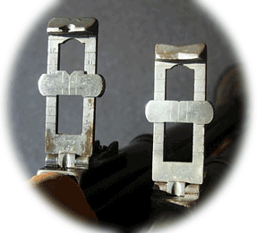
Here we see the two variants of the Rear sight, to the right the early Mk1 pattern, shallow notch. Note the groove at the axis point to allow 50 yard sighting.

To The left is the Mk2-Mk4 ladder sight, note the deeper notch and lines for windage allowance. The graduations from 500-1200 yards are visible

Martini Henry Rifles of the Anglo Zulu Wars
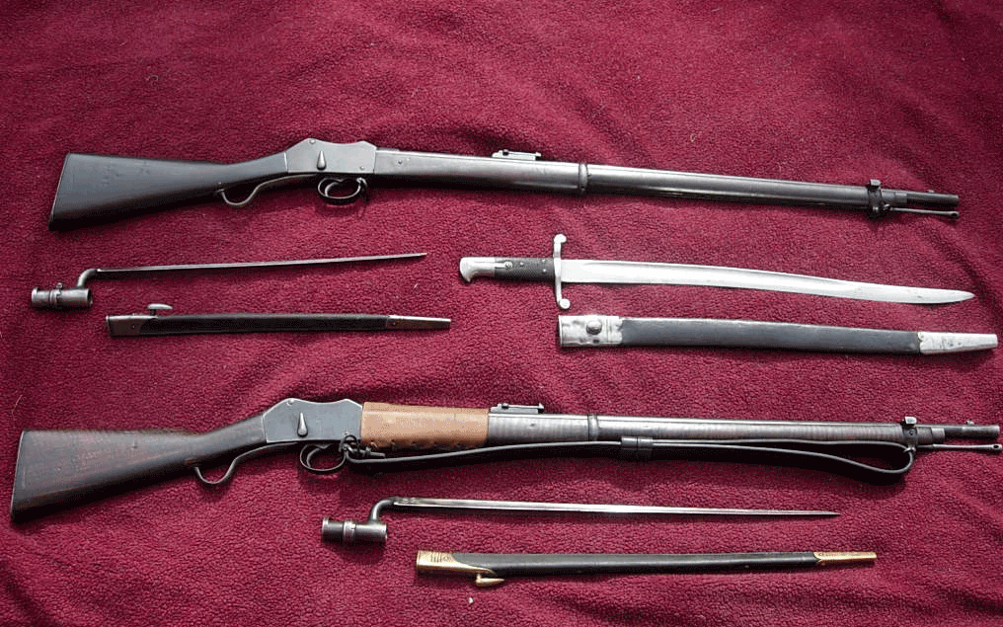

Top: P1874 Mk1 3rd Pattern Martini Henry Rifle Bottom: P1877 Mk2 Martini Henry Rifle
Bayonets Top Left: P1853/74 17” socket bayonet Top Right: P1853 Yataghan sword bayonet (issued to NCO’s), Bottom: P1876 22” Socket bayonet “the Lunger”

The Third pattern Mk1 P1874 Martini Henry was to form the backbone of the British infantry small arms between 1874-80. During early trials, the bronze axis pin originally fitted was found to be unsuitable, so, a small split pin, made of spring steel was installed. The two-part trigger tumbler was also omitted and a re-designed single piece added. Significant changes were made to the extractor and a tougher version was installed.

By Aug 1877 an new updated Martini Henry was included into the military arsenal, designated as the Mk11 Martini Henry. The Mk11 had various alterations made, upgrading the various flaws, which were found during service. The cleaning rod was re-designed, the rear sight ladder had a deeper notch fitted to allow better sighting, also the internal trigger mechanism was re-designed, a new breech block was designed to allow the escape of gases, plus, the extractor claw was strengthened. A final cosmetic change was that the chequering of the Mk1 butt-plate was smoothed as it transferred dirt to the tunic. Most Mk1 rifles in service were upgraded to the Mk2, a simple extra Arabic “1” added to the existing mark classification.

Most of the service Martini rifles of the Anglo Zulu wars were the Mk1 3rd pattern, despite a heavy programme of conversion to the Mk2 variant, by March 1879 only 175,000 of the 420,000 manufactured Mk1’s had been returned to Enfield for conversion, with a further 225,000 being programmed for 1879 (actually 1.3.79-1.3.80 as Enfields’ production year was not calender). Regiments issued with Mk1 and on active service were not to be upgraded until their return to depot.

In 1877 saw the introduction of the IC1 Carbine (Below), in two designations, the Cavalry and the Artillery. The gun utilised the same breech action of the MHR but had a shorter barrel. The ammunition was a reduced sized bullet and a smaller powder load, 70 grains. The example below is a cavalry carbine, notice the screw under the sight ladder, this was for a leather sight protector, also is the lack of a bayonet bar on the front band.

The IC1 carbine saw no service in the first phases of the Anglo Zulu was, as it was not until late 1878 that it was issued in a large scale to home based forces, until that time the British mounted infantry and the colonial forces utilised the Swinburn Henry Carbine, from the exterior the Swinburn resembled a standard Martini action, however the internal workings were completely different, its main design variant was the rifle was cocked via a large thumb-piece on the cocking indicator, not the underlever (which simply ejected the case). This was a huge benefit to mounted men as it meant a round could be left in the breech, whilst being stored in the saddle of on its sling, it could be cocked and fired rapidly.

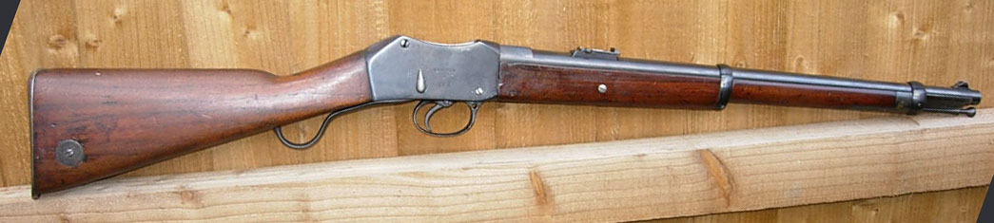

Below: The Swinburn Henry .450/577 Carbine
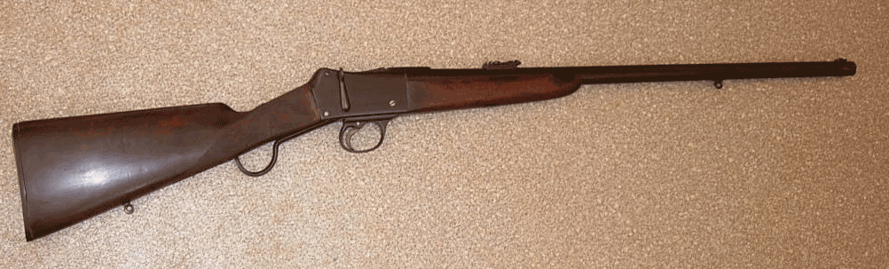

Ammunition

The Martini Henry rifle utilised the Boxer cartridge, a foil brass round rolled around a mandrel, with a steel base plate. The primer was a Berdan primer containing Fulminate of Mercury. The idea of the foil round was to expand on firing and create a good seal, however the three part construction was prone to falling apart on firing, or, jamming into the chamber if not ejected quickly, due to the brass softening. In the picture below are the various rounds and bullets of the period. The bullets were supplied in paper packets of 10 rounds. These in turn were supplied in hardwood storage boxes of 60 packets.

Left: A .577/.450” Mk3 Martini Henry rifle round. 480 grain lead bullet. White paper jacket.
Middle: A .577/.450” Martini Henry Carbine round. 410 grain bullet. Red paper Jacket.
Third Left: A .577 Snider round. Later drawn brass case. Top right a .591” snider bullet.
Bottom right: A .450 Pistol round.

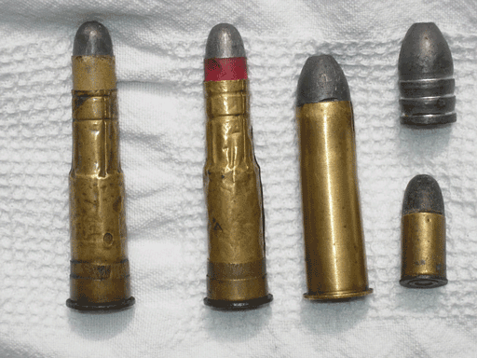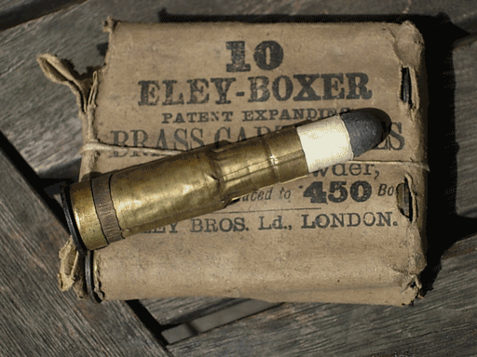

The Martini as a front line rifle was to serve the British army and its colonial forces until 1890, whereby a lot were re-barrelled to take .303” cartridges. The Advent in 1888 of the Magazine Lee Metford, and in 1893 of the Magazine Lee Enfield saw the Martini Henry gradually be reduced to surplus stores for conflicts which the Machine Gun, barbed wire and Gas were to rule supreme.

Appendix 1
Colonel E M Boxer had developed his .577 cartridge for the Snider as a replacement for the original cardboard walled round. It was simple, a brass sheet was rolled around a mandrel, to which a brass and steel base was affixed. The round contained its primer, powder, wad and lubricant. The resultant explosion caused the round to expand width-wise to provide an effective seal and prevent the escape of propellant gasses.

